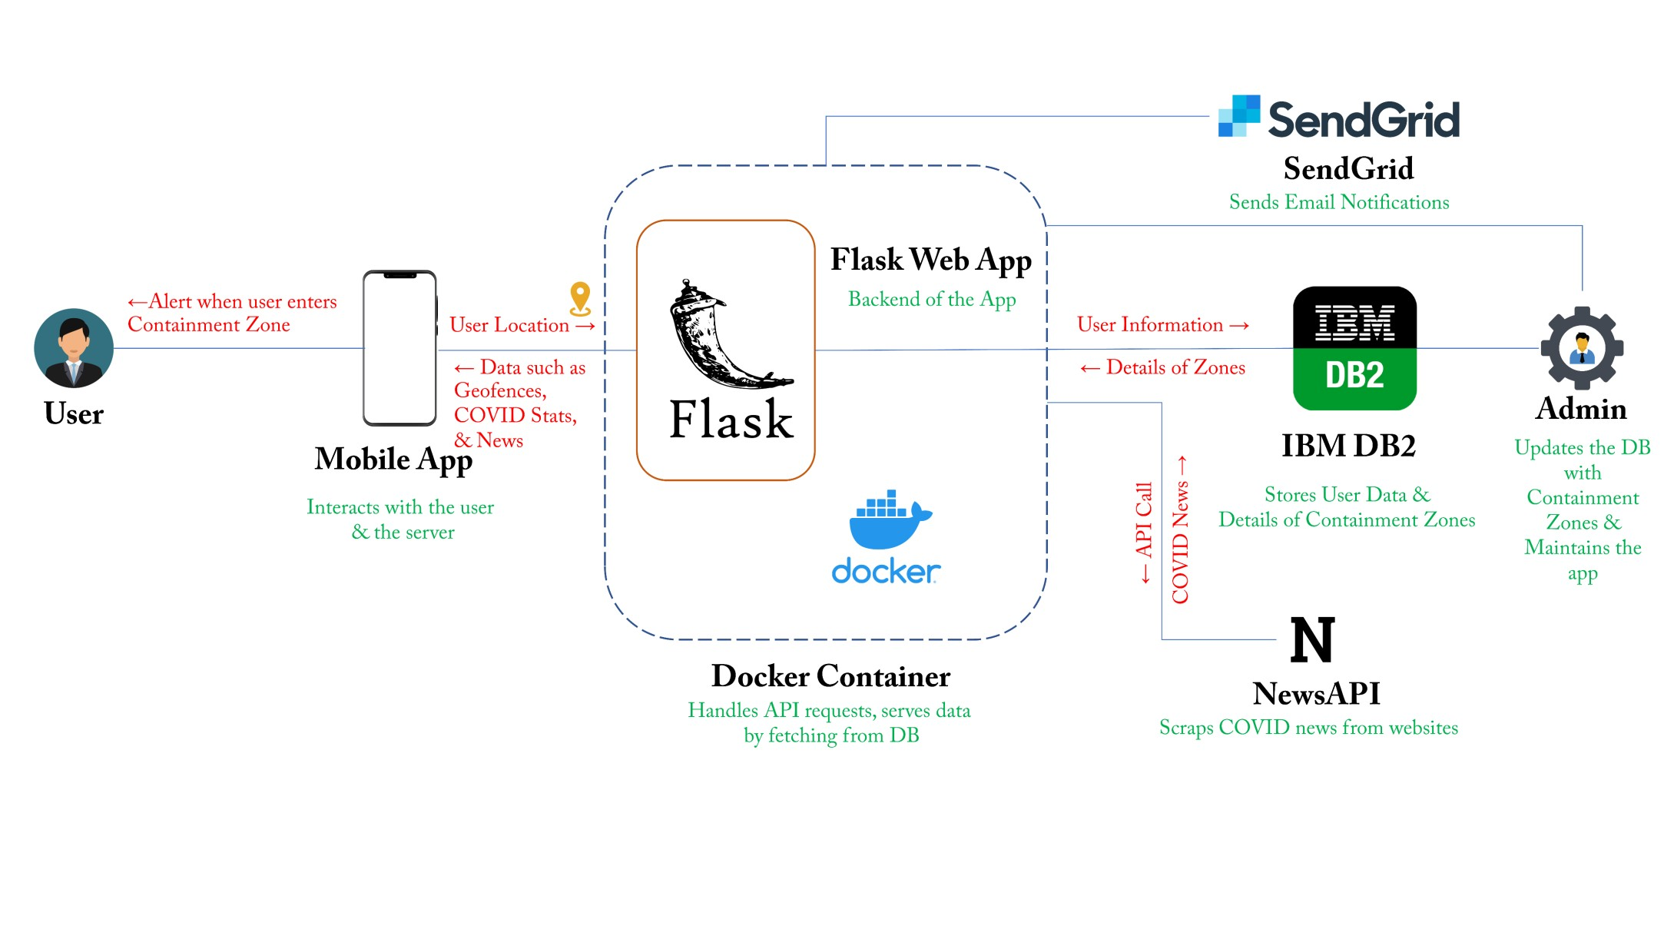Containment Zone Alert Application Project Design Phase II Technical Architecture Team ID: PNT2022TMID31914